DNS query

❓ What is a DNS Query?
# Source: AI Source: Provided by: [Data Path: Persons Table -> ID Column: 1, Name_En Column: Motasem Essam] -> From: [ChatGPT] on [1/18/2026]
A DNS query is a request made by a computer (usually through a browser or app) to the Domain Name System (DNS) to resolve a domain name (like google.com) into an IP address (like 142.250.190.14) or other DNS record.
🧠 Think of a DNS query as asking the internet's "phone book":
“Hey, what’s the IP address of www.example.com?”

To resolve a domain name means to translate a human-readable web address (like www.google.com) into a machine-readable IP address (like 142.250.190.14), which is needed for devices to communicate over the internet.
🧠 "Resolving" is the process of finding the real address behind a website name.

🧭 How a DNS Query Works (Simplified)
# Source: AI Source: Provided by: [Data Path: Persons Table -> ID Column: 1, Name_En Column: Motasem Essam] -> From: [ChatGPT] on [1/18/2026]
- You type www.example.com in your browser.
- Your computer sends a DNS query to a recursive resolver.
- If not already cached, the resolver queries:
  - 🔍 A Root DNS Server
  - 🔤 A TLD Server (like .com)
  - 🏁 An Authoritative DNS Server (for example.com)
- The IP address is returned and used to connect to the website.

📄 Types of DNS Queries
# Source: AI Source: Provided by: [Data Path: Persons Table -> ID Column: 1, Name_En Column: Motasem Essam] -> From: [ChatGPT] on [1/18/2026]
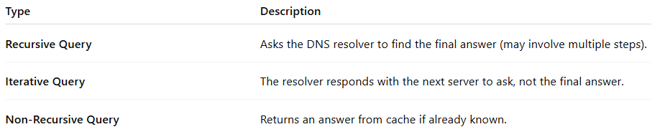

Type | Description
Recursive Query | Asks the DNS resolver to find the final answer (may involve multiple steps).
Iterative Query | The resolver responds with the next server to ask, not the final answer.
Non-Recursive Query | Returns an answer from cache if already known.

🗂️ What Can a DNS Query Ask For?
# Source: AI Source: Provided by: [Data Path: Persons Table -> ID Column: 1, Name_En Column: Motasem Essam] -> From: [ChatGPT] on [1/18/2026]
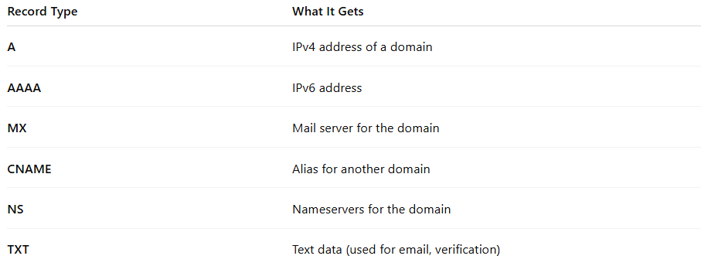

Record Type | What It Gets
A | IPv4 address of a domain
AAAA | IPv6 address
MX | Mail server for the domain
CNAME | Alias for another domain
NS | Nameservers for the domain
TXT | Text data (used for email, verification)

🧪 Example DNS Query (using dig)
# Source: AI Source: Provided by: [Data Path: Persons Table -> ID Column: 1, Name_En Column: Motasem Essam] -> From: [ChatGPT] on [1/18/2026]
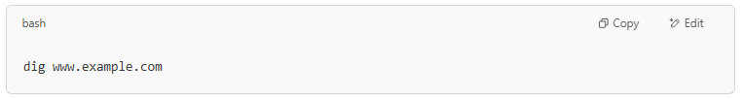
dig www.example.com

✅ Summary
# Source: AI Source: Provided by: [Data Path: Persons Table -> ID Column: 1, Name_En Column: Motasem Essam] -> From: [ChatGPT] on [1/18/2026]

DNS Query = A question asking for information about a domain
🔍 Usually asks: “What is the IP of this domain?”
📡 Sent to recursive or authoritative DNS servers
🔁 Happens every time you visit a website

